**Instructions**

* Save your file as surnameforename.html.
* Use embedded style sheets.
* Once you have completed the exam, email your file to [anne.obrien@staff.ittralee.ie](mailto:anne.obrien@staff.ittralee.ie)
* Do not leave until I have received your exam.
* Please keep a copy of the exam until you get your results back.

**Screen Capture**

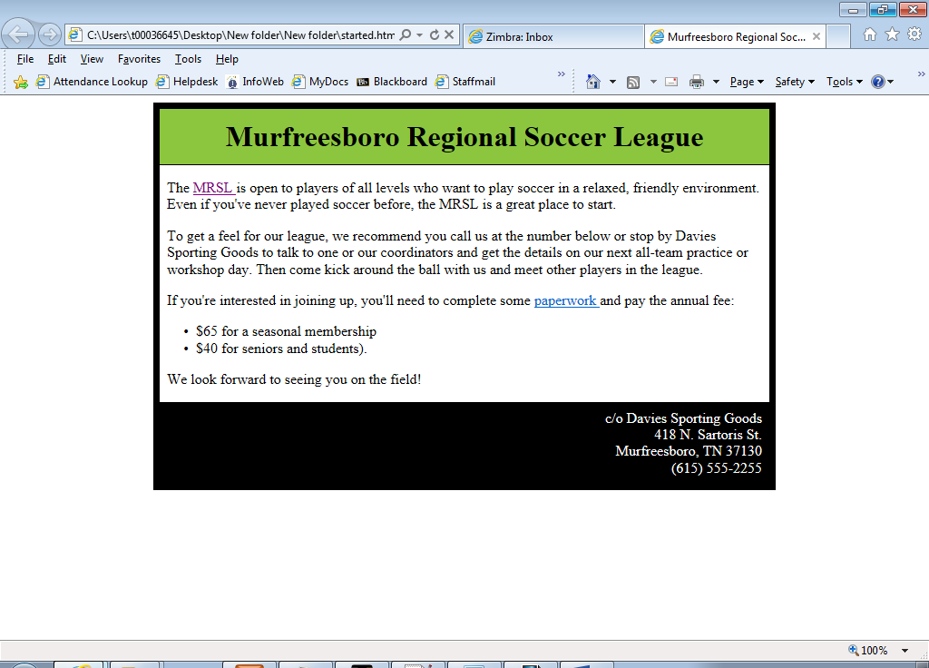

**Links**

MRSL should link to: <http://www.mrsl.org/league/>

Paperwork : Based on the chart below and presuming you are in index.html, what would be the relative link to registration.html

**Text**

# Murfreesboro Regional Soccer League

The MRSL is open to players of all levels who want to play soccer in a relaxed, friendly environment. Even if you've never played soccer before, the MRSL is a great place to start.

To get a feel for our league, we recommend you call us at the number below or stop by Davies Sporting Goods to talk to one or our coordinators and get the details on our next all-team practice or workshop day. Then come kick around the ball with us and meet other players in the league.

If you're interested in joining up, you'll need to complete some paperwork and pay the annual fee:

* $65 for a seasonal membership
* $40 for seniors and students).

We look forward to seeing you on the field!

c/o Davies Sporting Goods  
418 N. Sartoris St.  
Murfreesboro, TN 37130  
(615) 555-2255

**Settings**

Background colours used are #8CC63F, #000000 and #ffffff

Main box has a width of 672px